Output from ArrayStackRealTopTestDriver for 12.4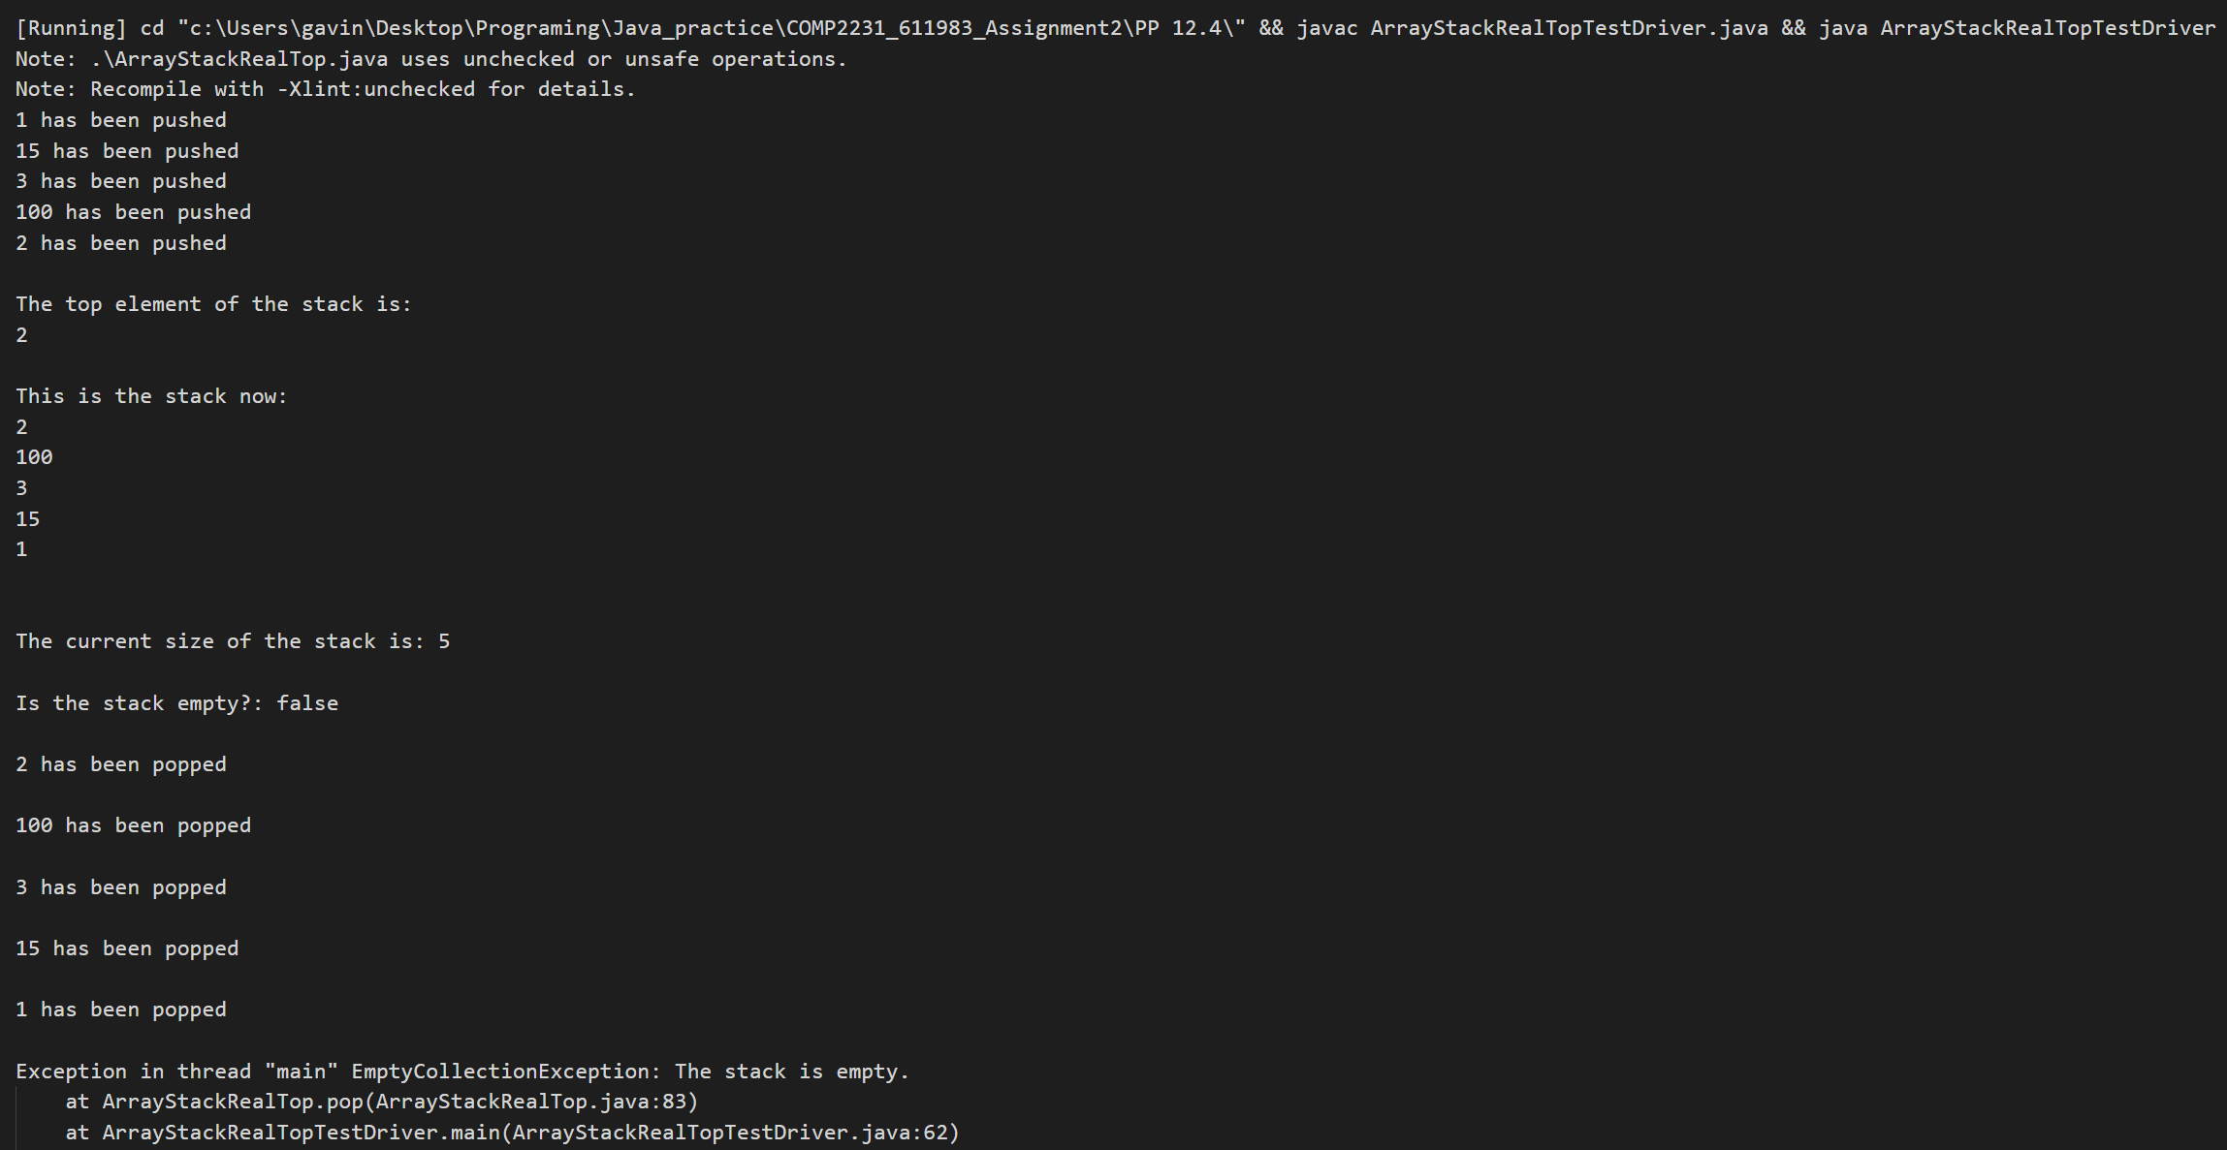

Output from DropOutStackTestDriver for 13.8

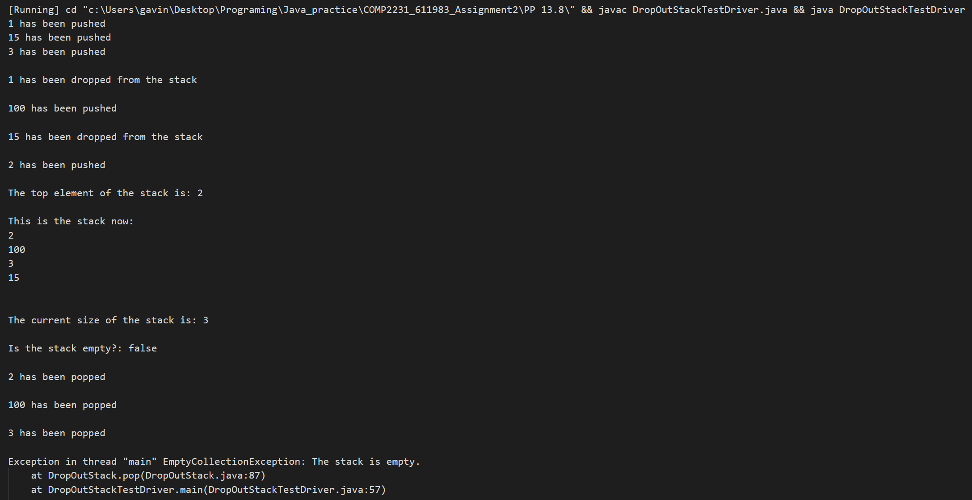

Output from DoubleEndedQueueTestDriver for 14.6

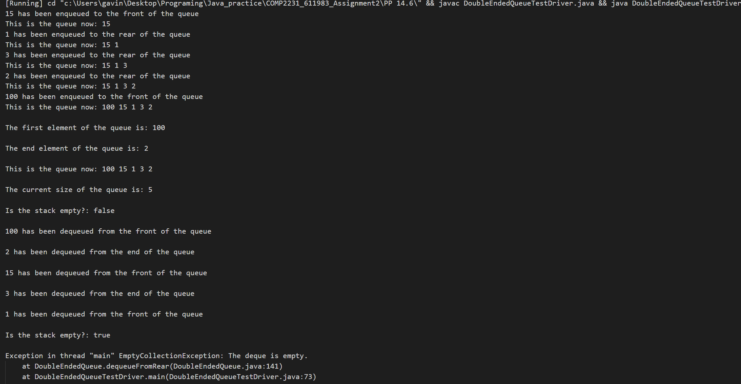

Output for DoubleEndedQuetestDriver for 14.9